- 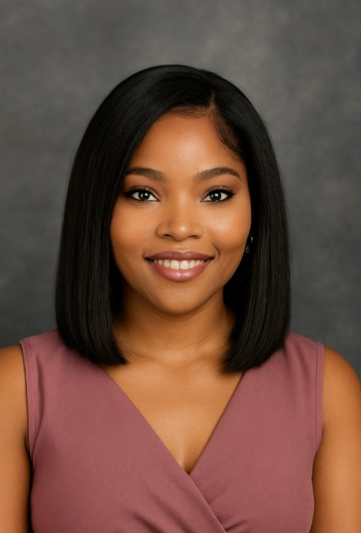 |  | - KHOLOFELO RAPOO
 |  | Meticulous and dependable administrative professional with over five years of experience in high-end retail, virtual assistance, and customer service environments. Highly skilled in data capturing, record management, document processing, and maintaining accurate client information. Recognised for strong attention to detail, confidentiality, and organisational efficiency. Adept at supporting teams in fast-paced professional environments and committed to ensuring operational accuracy and compliance.
- Contact  Alberton, South Africa  Rapookholo@gmail.com  +2763 408 1096  - Education  boston business college  Office Administration certificate  providence academy  Matric  PREPLY  TEACHING ENGLISH AS A FOREIGN LANGUAGE  - Skills  Customer support & inquiry resolution  Client retention  Complaint resolution  Follow-ups  TECHNICAL SKILLS  Microsoft Office Suite  Google Workspace  Virtual Platforms  CRM Systems  Basic Data Reporting  Outlook  PERSONAL ATTRIBUTES  Detail-Oriented  Reliable & Punctual  Professional & Discreet  Strong Organisational Skills  Ability to Work Independently & in a Team |  | Experience  virtual assistant  Cybersec security | remote | Feb 2024- July 2025  Captured and updated client information into CRM systems with high accuracy.  Maintained digital filing systems and ensured proper document categorisation.  Managed email correspondence and organised confidential documentation.  Assisted with data entry, spreadsheet management, and report preparation.  Verified information before submission to ensure compliance and accuracy.  front desk receptionist  Posh Multimedia Academy | Braamfontein | Nov 2022- Oct 2023  Welcomed and directed visitors, creating a professional and customer-friendly first impression.  Managing incoming calls, screening and redirecting inquiries promptly.  Coordinated appointment scheduling with 95% accuracy, reducing double-bookings and delays.  Supported cross-department communication by relaying messages promptly.  sales consultant  Swarovski | Mall of the south | FEB 2021-MAR 2022  Delivered personalised client consultations, consistently exceeding individual and store sales targets.  Upsold complementary jewellery pieces through expert product knowledge and relationship-based selling.  Maintained high customer satisfaction ratings by providing attentive, detail-oriented service.  Processed transactions accurately and managed daily cash handling procedures.  Assisted with visual merchandising and maintaining premium in-store presentation standards.  receptionist  Rock Media | Midrand | APR 2019-AUG 2020  Managed email correspondence, phone inquiries, and client bookings efficiently.  Maintained organised filing systems and accurate data entry records.  Coordinated schedules, meetings, and operational logistics.  Resolved customer queries promptly, ensuring positive resolutions and repeat business.  Supported daily office operations to ensure smooth workflow and team productivity.  Luxury sales consultant  Maison Corthay | Sandton | AUG 2015-DEC 2018  Provided high-end, bespoke customer service to an international clientele.  Built long-term client relationships through tailored recommendations and follow-up communication.  Managed appointment scheduling and coordinated client fittings.  Handled administrative tasks including inventory tracking, order processing, and record keeping.  Represented the brand with professionalism, discretion, and refined product expertise.  Maintained detailed client records and product documenta
References available upon request

